Rental

# ERD for UX process

Place your ERD diagram here.

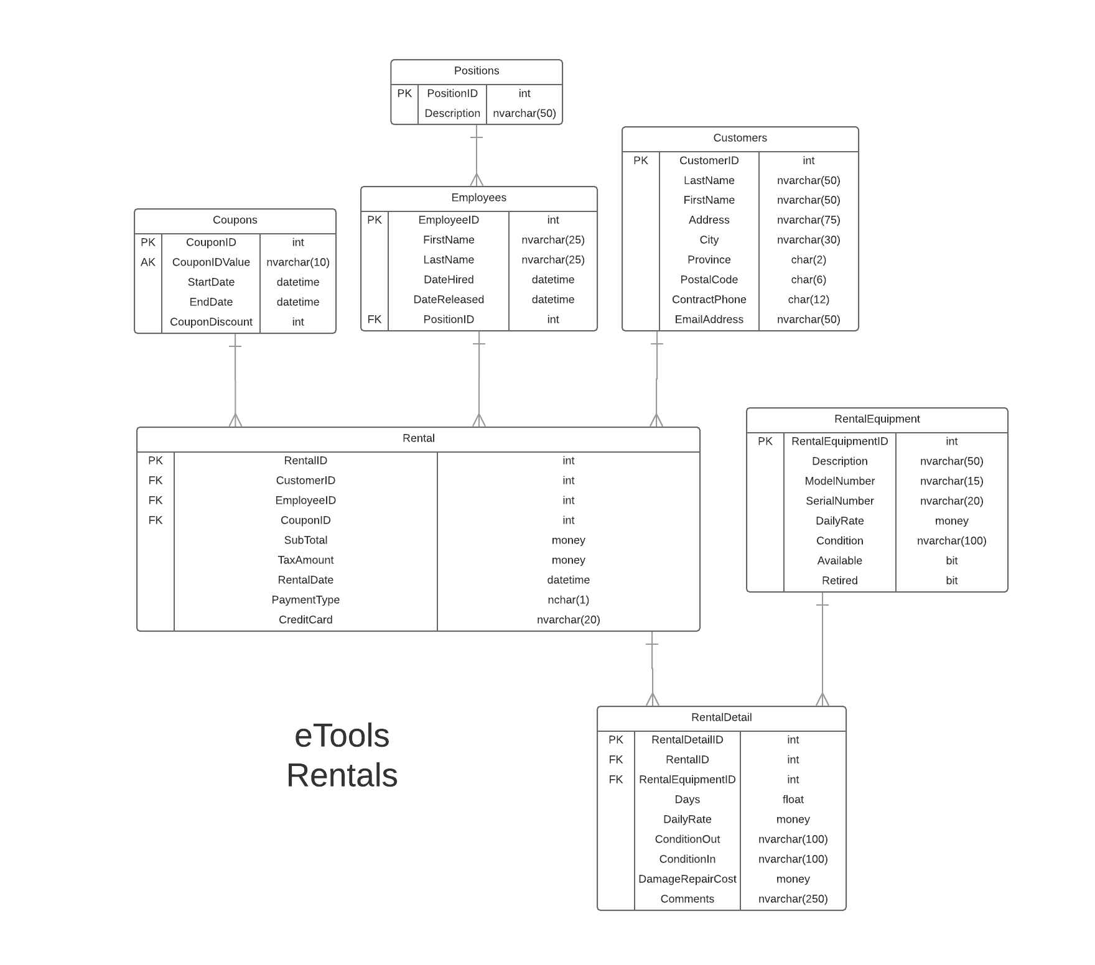

# Possible UX Interface

Place your screen design(s) here

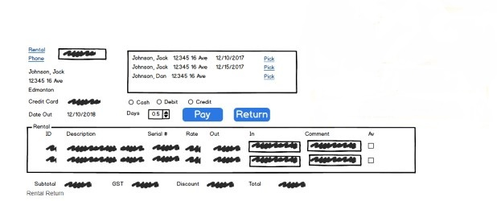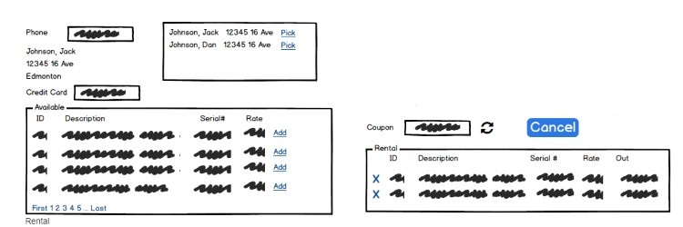

# Event and Wiring Summations

|  |  |  |
| --- | --- | --- |
| **Controls** | | **Events** |
| CustomerTextBox, CustomerSearchButton, CustomerSelectionListView | | OnClick   * Validate input * ~~Move entered value too phoneNumber~~ * Bind results with CustomerSelectionView |
| **BBL Class(s) and Method (s)** | | |
| CustomerController | List<CustomerSelection>List_Customer(string phoneNumber)  Retrive customers by entered phone number. Return full name, address, | |
| **SQL Table(s): (C,R,U,D)** | | **Entities/DTOs/POCOs** |
| Customer(R) | | CustomerSelection(P) |

|  |  |  |
| --- | --- | --- |
| **Controls** | | **Events** |
| AddCustomerButton, CustomerInfoLabel, CreditCardTextBox | | OnClick   * Update CustomerInfoLabel * Update CreditCardTextBox |
| **BBL Class(s) and Method (s)** | | |
| CustomerController | CustomerProfile List_ getSingleCustomerSelection ()  Retrive one customer profile and update CustomerInfoLabel.  TRX(Create empty rental cart) | |
| **SQL Table(s): (C,R,U,D)** | | **Entities/DTOs/POCOs** |
| Rental(C), Customer(R) | | CustomerProfile(DTO), EquipmentRental(P) |

|  |  |  |
| --- | --- | --- |
| **Controls** | | **Events** |
| CreditCardTextBox, AvailableRentalEquimentListView | | OnClick   * Validate/Verify Credit Card * Bind rental data to AvailableRentalEquimentListView |
| **BBL Class(s) and Method (s)** | | |
| RentalEquimentController | List<EquipmentRental> List_ EquipmentRental(), retun equipment id, description, serialNumber, Rate. | |
| **SQL Table(s): (C,R,U,D)** | | **Entities/DTOs/POCOs** |
| RentalEquiment(R) | | EquipmentRental(P) |

|  |  |  |
| --- | --- | --- |
| **Controls** | | **Events** |
| CouponCheckBox | | OnClick   * Validate/Verify Coupon |
| **BBL Class(s) and Method (s)** | | |
| RentalController | Bool isValidCoupon(string coupon)   * Check if valid | |
| **SQL Table(s): (C,R,U,D)** | | **Entities/DTOs/POCOs** |
| Rental(U) | |  |

|  |  |  |
| --- | --- | --- |
| **Controls** | | **Events** |
| AddRentalButton, CustomerProfileCartView | | OnClick   * Add equipment to cart * Bind rental data to Customer profile cart |
| **BBL Class(es) and Method (s)** | | |
| CustomerController | void getSingleEquipment( EquipmentRental eq).  Add equipment to cart, equipment enumeration | |
| **SQL Table(s): (C,R,U,D)** | | **Entities/DTOs/POCOs** |
| Rental(C), Customer(R), RentalEquiment(R) | | CustomerProfile(DTO), EquipmentRental(P) |

|  |  |  |
| --- | --- | --- |
| **Controls** | | **Events** |
| RemoveRentalButton, CustomerProfileCartView | | OnClick   * remove equipment to cart * Bind rental data to Customer profile cart |
| **BBL Class(es) and Method (s)** | | |
| CustomerController | void removeSingleEquipment( EquipmentRental eq). | |
| **SQL Table(s): (C,R,U,D)** | | **Entities/DTOs/POCOs** |
| Rental(C), Customer(R), RentalEquiment(R) | | CustomerProfile(DTO), EquipmentRental(P) |

|  |  |  |
| --- | --- | --- |
| **Controls** | | **Events** |
| ReturnProfileSelectionLabel, RentalReturn basket, ReturnProfileSelectionTextBox | | OnClick / Wired via ObjectDataSource |
| **BBL Class(s) and Method (s)** | | |
| CustomerController | CustomerProfile customer  getCustomerPhoneOrAcountNumber(string input)   * Retrive based on input- check if phone number or account number * Get customer profile   void updateCustomerLabels(string input)   * update default(empty) customer information string * Update UI with customer profile information   void returnEquipment(EquipmentRental toReturn)   * Check equipment condition and available is selected | |
| **SQL Table(s): (C,R,U,D)** | | **Entities/DTOs/POCOs** |
| Customer(R), EquipmentRental(u) | | CustomerReturn(DTO), EquipmentRental(P) |

|  |  |  |
| --- | --- | --- |
| **Controls** | | **Events** |
| PaymentRadioButtons, Paybutton | | OnClick   * Check if payment type is selected * Pay amount and update details * Apply Coupon Value |
| **BBL Class(es) and Method (s)** | | |
| RentalDetailController | Void payAmount(PaymentType type) | |
| **SQL Table(s): (C,R,U,D)** | | **Entities/DTOs/POCOs** |
| RentalDetail(U) | | CustomerProfile(DTO) |

|  |  |  |
| --- | --- | --- |
| **Controls** | | **Events** |
| AvaliableCheckBoxBox, ReturnButton | | OnClick   * Check equipment condition and available is selected * Pay amount and update details |
| **BBL Class(es) and Method (s)** | | |
| RentalDetailController | Void returnEquipment() | |
| **SQL Table(s): (C,R,U,D)** | | **Entities/DTOs/POCOs** |
| RentalEquipment (U) | | CustomerProfile(DTO) |

Comments

You need to refine your work. You seem to display an understanding of the overall subsystem at a high level but your document lacks design details and is at points, confusing.